**PROJECT PROPOSAL**

**Rural Cultivation and Atmospheric Emulation Application**

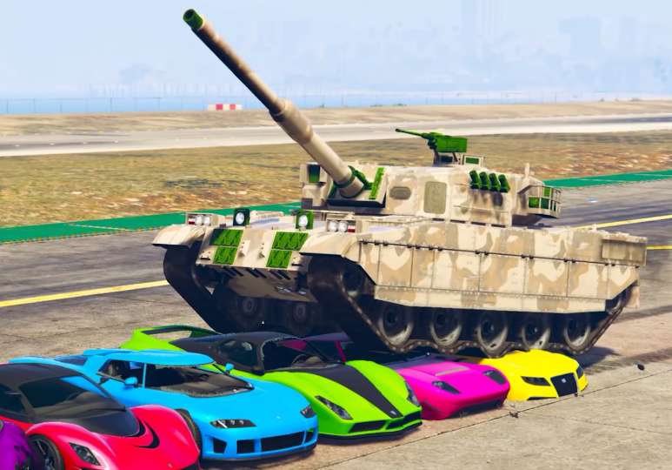

***Tanks & Co.™***

1. **PROJECT DESCRIPTION**
   * Project Title: **Tanks & Co.’s RCAEA Project**
   * Organization: Tanks & Co.™
   * Number of Participants: 6
   * Project Start Date: 01/09/2016
   * Project Implementation Date: 15/01/2017
   * Project Presentation Date: 24/01/2017
2. **Executive Summary**

The creation of an Agricultural Simulation; The application will replicate a cultivation area where the user can select which crops they would like to grow in a designated region. The Application will then aid the user by simulating the most likely produce and cost outcomes based on an array of external and internal factors.

1. **Statement of the Problem**

* **Who are we?**

Tanks & Co.™ is a small software development team composed of just six developers based in Eindhoven that crushes the competition.

* **Goals:**

We wish to develop an agricultural simulation application that SIM Software will take interest in and eventually buy.

* **Features:**
* The application will feature an adjustable land surface size
* Selectable crops(one-use or multiple harvesting seeds) and regions
* The ability to scale through time.
* A database with regional weather and soil properties
* A database of crops and their properties
* The ability to select crops and fertilizers, as well as the land area to cultivate.
* Calculate an estimation of produced crops and profits
* Calculate an estimation of costs
* Detailed but simple application interface for easier usability
* Tracking of the fertility of the land
* Save/Load previous simulations

1. **Technical Approach**

* **The Database:**
  + Will hold weather patterns and temperatures per month based on previous weather patterns.
  + Will hold similar crop and soil properties such as required growth time, prices and amount of water needed
  + Will store saved previous simulations data.
* **The Application:**
  + Will use the data from the database
  + Will calculate user input along with region and crops used to produce a yield and cost estimation
* **The Design:**
  + A Project Plan has been created which Tank & Co.™ will follow according to the phases entailed
  + The User Requirements Specification (URS) for the application shall contain both functional and non-functional requirements.

1. **DETAILED BUDGET**

|  |  |  |
| --- | --- | --- |
| **Employee** | **Description** | **Monthly Salary** |
| Richard Dyer | Project Leader | €8.000 |
| Raima Khan | Contact Person | €6.500 |
| Tsanko Hadzhiev | Minute Keeper, Designer | €350 |
| Mihail Hadzhinikolov | Software Designer | €5.500 |
| Zisis Damianidis | Software Designer | €5.500 |
| Al-Mohaiminul Islam Khan | Software Designer | €5.500 |

1. **Communication with Sponsor**

* Weekly meeting with client's representative from SIM Software will ensure that the progress of the project is monitored until its completion.